Enr. No. : 2302030430007

Assignment : 1

[Ans 1 : ]

Step 1: click on the “New” button to create a new repository.

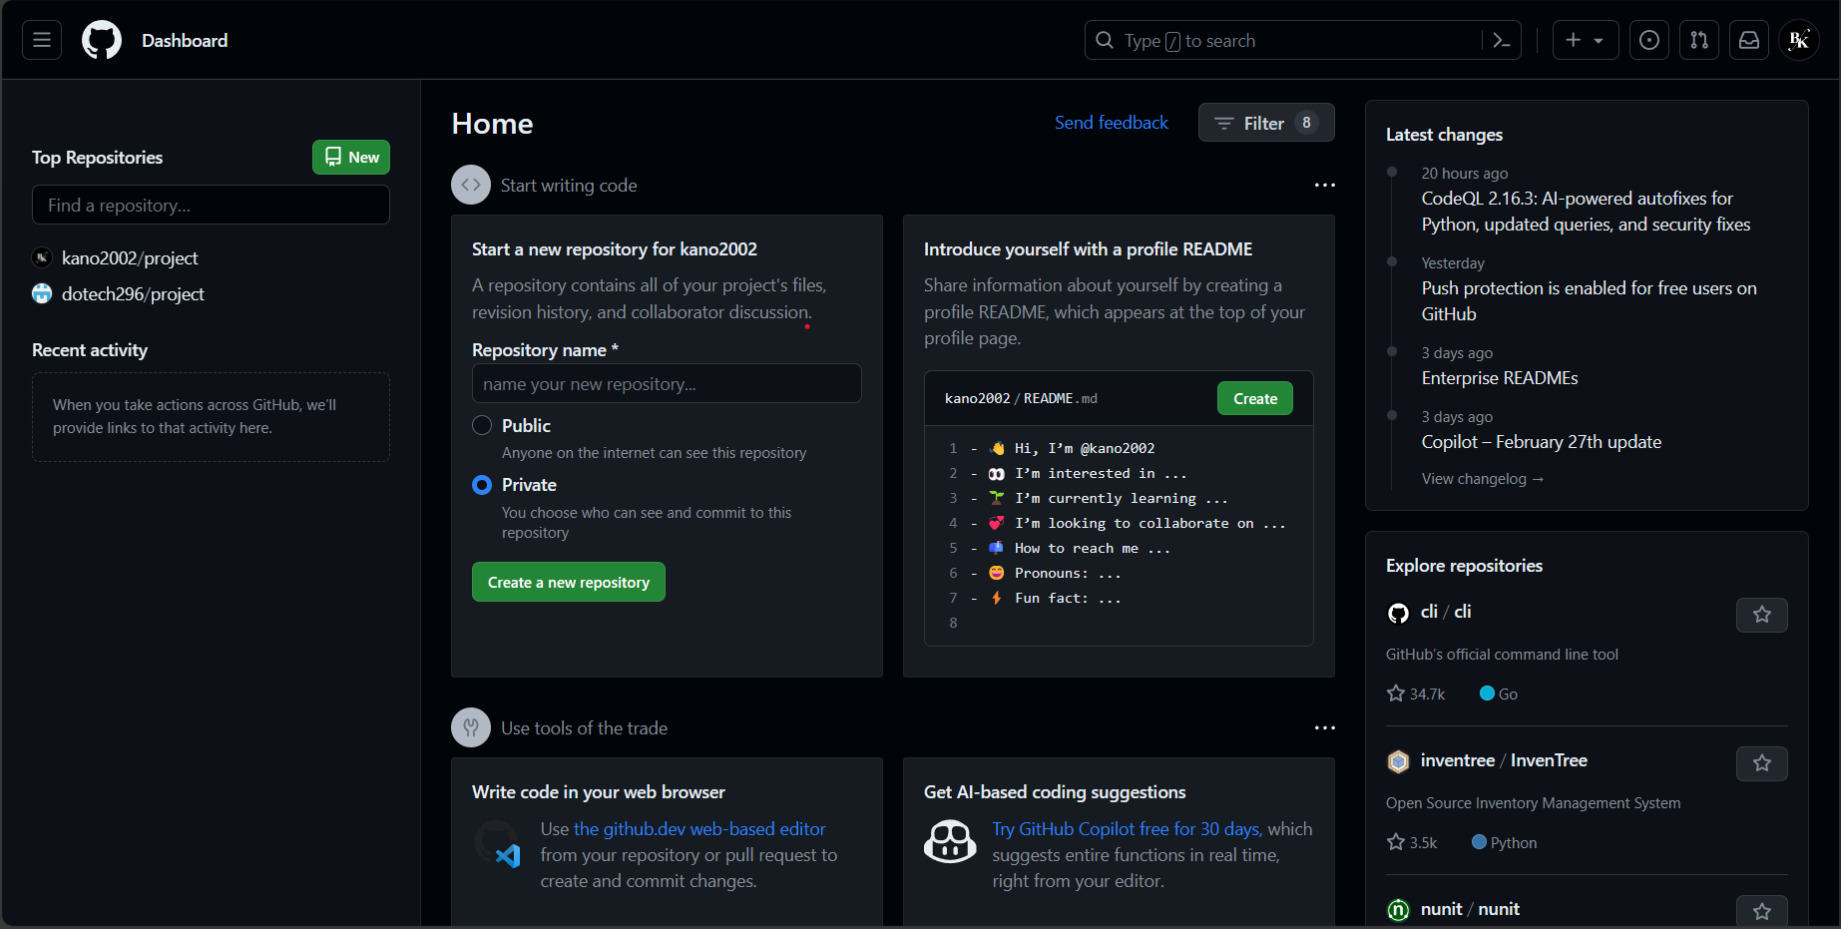

Step 2 : Give the name of the repository. Make it public or private by clicking on the given options. Add a README file if you want to. After that click on the “Create repository” button.

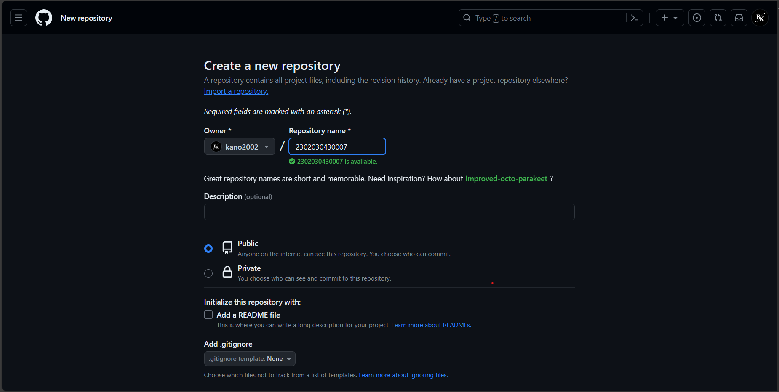

Like that, your GitHub repository has been created successfully.

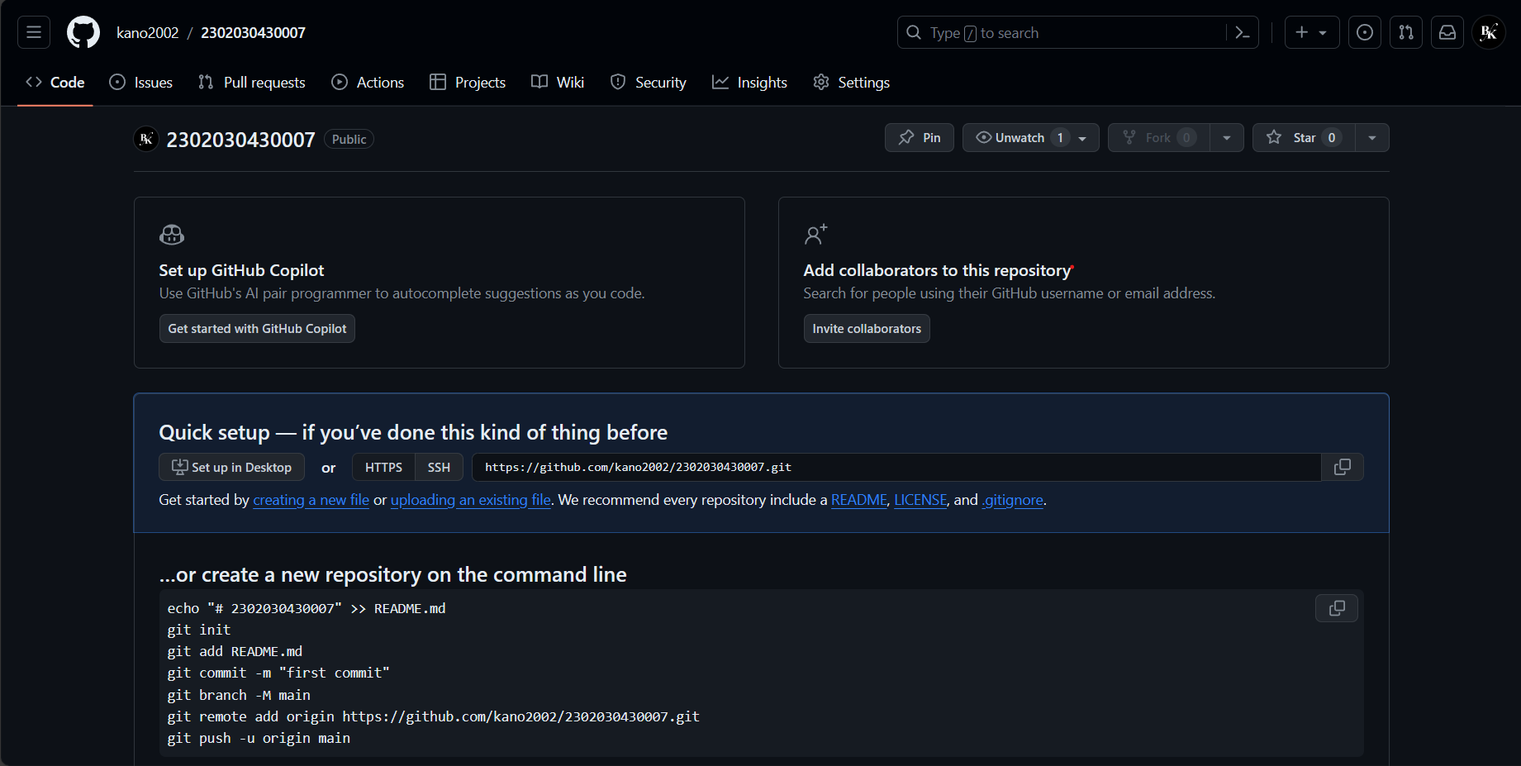

Step 3 : Scroll down and you will see the option for importing code.

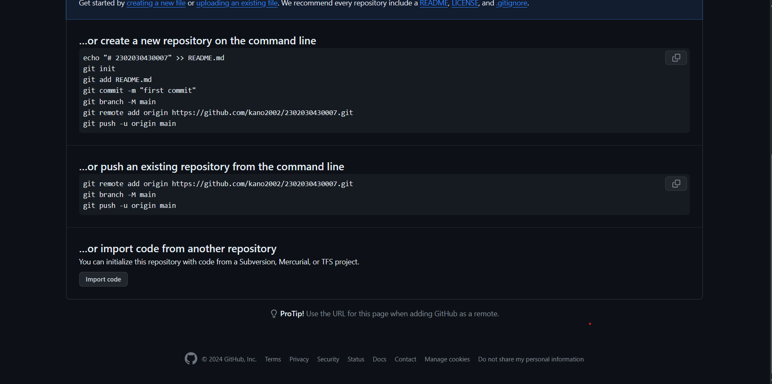

Step 4 : After, following this command and push your file or code.  
  
- git add .  
- git commit -m "commit name"  
- git push origin branch_name